Hough_Grd(imgfltrd, 6, 0.3) Hough_Grd(imgfltrd, 6, 0.4)

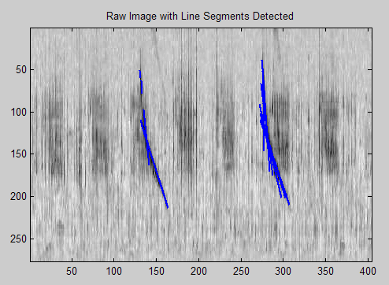 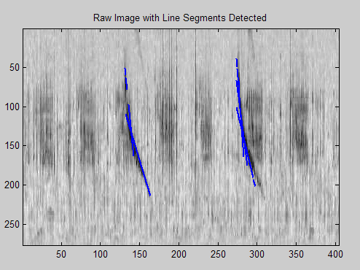

Hough_Grd(imgfltrd, 6, 0.5) Hough_Grd(imgfltrd, 6, 0.2)

